caBIG®
Clinical Information Suite

Design Test Plan

Author : Kevin Gann
Ekagra Software Technologies, Ltd
Team : caBIG QA
Subcontract : 29XS223STO1

Document Change History
Version Number | Date | Contributor | Description
V0.1 | 6/25/2010 | Kevin Gann | Initial outline
V0.2 | 10/15/2010 | Brian Bell | Updated state of Analysis artifact review process
V0.3 | 2/28/2011 | Brian Bell | Moved Analysis QA process to Requirements Test Plan


Updated February 28, 2011
Table of Contents

1 Introduction 3
1.1 Design Test Approach 3
1.1.1 Traceability 3
1.2 Relationship to Other Documents/Plans 4
1.3 Definitions, Acronyms and Abbreviations 5
1.4 Scope 6
1.4.1 In Scope 6
1.4.2 Out of Scope 6
1.5 Roles and Responsibilities 6
1.5.1 Analysis DSL/Stream 6
1.5.2 Architecture DSL/Stream 6
1.5.3 Development DSL/Stream 7
1.5.4 QA DSL/Stream 7
2 Test Methods 8
2.1 Design Test Artifacts 8
2.2 Test Reporting 8
3 Design Test Toolset 9

Introduction
The National Cancer Institute’s (NCI) Cancer Electronic Health Record, or “caBIG”, project will develop service specifications that will work in concert with existing EHR systems to address the unique needs of the ambulatory oncology community and addresses, in particular, the need for that community to work effectively within the broader research and oncology care environments.

This document describes the methods used to verify and validate analysis artifacts and that key inputs and dependencies are accurately represented within the domain analysis model (DAM) as required for the Quality Assurance aspects of the caBIG project.

This version of the document outlines the state of the Design Test Plan as of Release 3 of the caBIG Clinical Information Suite Project.

Design Test Approach
The caBIG Clinical Information Suite Project identifies:
- Design,
- Architecture,
- Requirements, and
- Enterprise Conformance and Compliance Framework (ECCF) Compliance testing
as part of the project’s overall quality assurance activities. Taken together, these four testing activities comprise Analysis & Architecture Quality Assurance.

The Design Test Plan covers the architectural design of the Enterprise Services Bus, platform and other Architecture team constructs.

To Do: This document remains to be completed. More information from Architecture is required about the deliverables to be produced for the system Architecture Design.

Relationship to Other Documents/Plans
The following caBIG Clinical Information Suite artifacts are relevant to the creation of this document:

Artifact Log # | Artifact Name |  | caBIG Team | RFP Deliverable Reference |  | Key inputs / Dependencies | Expected Content
12 | Scope & Vision - Project |  | Analysis |  |  |  | Overall project and business capability scope
19 | Domain Analysis Model | Analysis |  |  | DAM | Use Cases, Data Elements/Concepts | The DAM is a domain analysis Model that depicts the static and dynamic content of the project's domain - caBIG. The DAM will include the class diagrams, activity diagrams, sequence diagrams and state diagrams.
20 | Quality Requirements Plan |  | Analysis | Software Requirements Specification |  | Deployment Scenarios, Stakeholder input, Product Owner | Reliability, performance capacity, security, extensibility/configurability, industry standards and conformance, client deployment, auditing, data integrity, usability, supportability and general principles (e.g., ROI)
 | Analysis Management Plan |  | Analysis |  |  | Quality Requirements Plan | Detailed requirements capture process
21 | Conceptual Functional Services Specification (CFSS) |  | Arch | TIRA |  | BAM, Use Cases, DAM | Description, Scope, Justification, Structure of Service, Context, Operations, Functional and Semantic Profiles, System Iterations, Conformance and Compliance Statements, Relevant Standards
35 | Service PIM |  | Arch |  |  | Conceptual Service Specification, Relevant Information Models, BAM, Use Cases, DAM | Relationship to CFSS, Information Model, Data Type Definitions, Operations, Profiles, Behavior/Dynamic Model, Conformance Statements, References, and Glossary
76 | Master Test Plan |  | QA | Test plan document |  | Scope/Vision, SAD | Overall Quality Assurance test plan
96 | Requirements Test Plan |  | QA | Test plan document |  | Analysis team traceability approach | Requirements Traceability
98 | Architecture Test Plan |  | QA | Test plan document |  | SAD | Architecture artifacts QA process
100 | Design Test Plan |  | QA | Test plan document |  | Design Documents, UML models | Analysis artifacts QA process
102  (merged with #98) | ECCF Compliance Test Plan (CFSS, PIM, PSM) |  | QA | Test plan document |  | ECCF Implementation Guide | How ECCF compliance will be verified for project artifiacts.  ** Note the content of this artifact has been merged with the Architecture Test Plan

For initial, high-level context, the reader is directed to the caBIG Master QA Plan document (artifact log #76), which describes testing terminology definitions and overall scope and approach to Quality Assurance on the project.

Definitions, Acronyms and Abbreviations
Domain analysis model: The term “domain analysis model” (DAM) has at least two distinct meanings in the literature. Consistent across both definitions (which are essentially differences in content and scope of included domain information) is the notion that a DAM is implementation independent, i.e. it restricts itself to describing the “what” of the domain-of-interest, specifically excluding any representation of the various aspects of the “how.” This distinction results in a representation that is “domain friendly,” i.e. the terms and constructs used in a DAM can easily be understood by domain experts.

A DAM can be vetted by domain experts while simultaneously providing sufficient rigor for “downstream” design and implementation activities. This is a critical, essential defining feature of a DAM, and results in the fact that a single DAM can give rise to N-number of compliant implementations that vary in everything from UI to persistence schema, but remain computationally semantically interoperable by virtue of their implementation of various semantic constructs of the DAM on which they are based. As discussed in the text, the BRIDG model – itself an instance of a DAM – was begun to provide an implementation-independent view of the static and dynamic semantics of a domain-of-interest that could be shared initially by HL7 and CDISC and more recently by HL7, CDISC, NCI, and FDA.
The two meanings of the term DAM are:
- Static content only. The more restrictive meaning of the term defines the scope of a DAM to be the definition, explication, and inclusion of the static structures-of-interest in the domain-of-interest. No dynamic content is included. Thus, if the DAM is represented using the iconography of the Unified Modeling Language (UML) -- the representational language of the BRIDG domain analysis model -- the restrictive use of the term means “the semantics specified by the collection of classes, instances, attributes, and relationships that collectively define the domain-of-interest.”
- Dynamic and static content. The more inclusive use of the term DAM – and the one that defines the scope of the BRIDG model – allows for a DAM focused on a specific domain-of-interest to include both static and dynamic content, i.e. to be an “analysis-level architectural representation of the domain-of-interest.” Again, referring to the use of UML, a “type 2 DAM” would include all of the static content of a “type 1 DAM” plus the additional semantics of various dynamic aspects of the domain-of-interest expressed as Activity Diagrams of various granularities, State (lifecycle diagrams), and Sequence Diagrams. By far the most common of these three dynamic views are Activity Diagrams. State Diagrams are usually required for < 10% of the classes in the static class diagram view, and Sequence Diagrams are usually restricted to understanding specific “interoperability scenarios” at an <<instance>> rather than “responsible party” level common to Activity Diagrams.

Scope

In Scope
The Design Test scope includes the following.
- The scope is restricted to analysis artifact quality assurance.
- Handoff o analysis artifacts to the Architecture Team.

Out of Scope
Considered beyond the scope of the caBIG Clinical Information Suite Design Test Plan:
- Requirements traceability is covered in the Requirements Test Plan.
- ECCF Compliance is covered in the Architecture and ECCF Compliance Test Plan.
- Compliance activities, as defined in the Master QA Plan.

Roles and Responsibilities
The following teams have roles associated with supporting the design analysis model.

Analysis DSL/Stream
Responsible for:
- Develop Use cases and requirements in collaboration with the Adopters. This forms the basis for development.
- Evaluate and approve implementation of architecture management tool.

Architecture DSL/Stream
Responsible for:
- CFSS – Conceptual Functional Service Specification
- Project-oriented Domain Information Model
- PIM – Platform Independent Model

Development DSL/Stream
Responsible for:
- SAD – Software Architecture Document
- PSM – Platform Specific Model
- Develop the system/application

QA DSL/Stream
Responsible for:
- Develop the Test Plan
- Ensure design analysis model is represented from contributing artifacts to dependencies.
- Create the Test Report

Test Methods

This section outlines the usage of a combination of methods to approach verification of the design.

Design Test Artifacts
The following artifacts will be produced.
Artifact # | Artifact Name | RFP Deliverable Reference | Key inputs / Dependencies | Expected Content
100 | Design Test Plan | Test plan document | Design Documents, UML models | This document
101 | Design Test Report | System Test Report | Analysis team’s iteration based artifact delivery | Iteration-based report.

Test Reporting

A test report from the design test plan would identify deficiencies in the DAM. There are many possibilities from invalid UML representation to lack of elements from a Use Case.

Design Test Toolset
In this section we provide an overview of the key tools required for requirements traceability. The following diagram provides an overview of the key components relating to traceability.

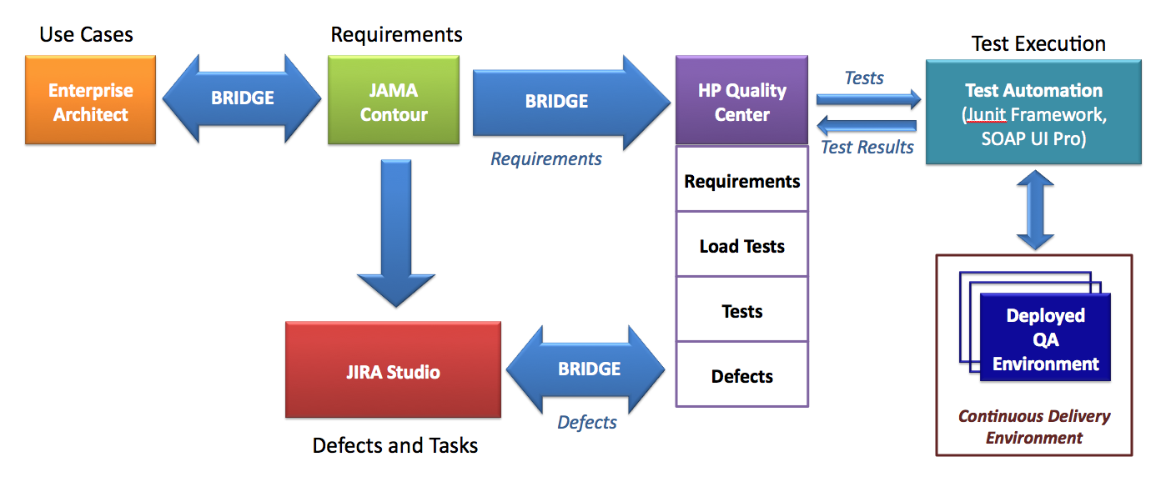

Enterprise Architect is used primarily by the Analysis and Architecture team to document the design specification. Requirements are identified and linked to Use Cases in Enterprise Architect. An example of requirements for the Referrals service are shown below:
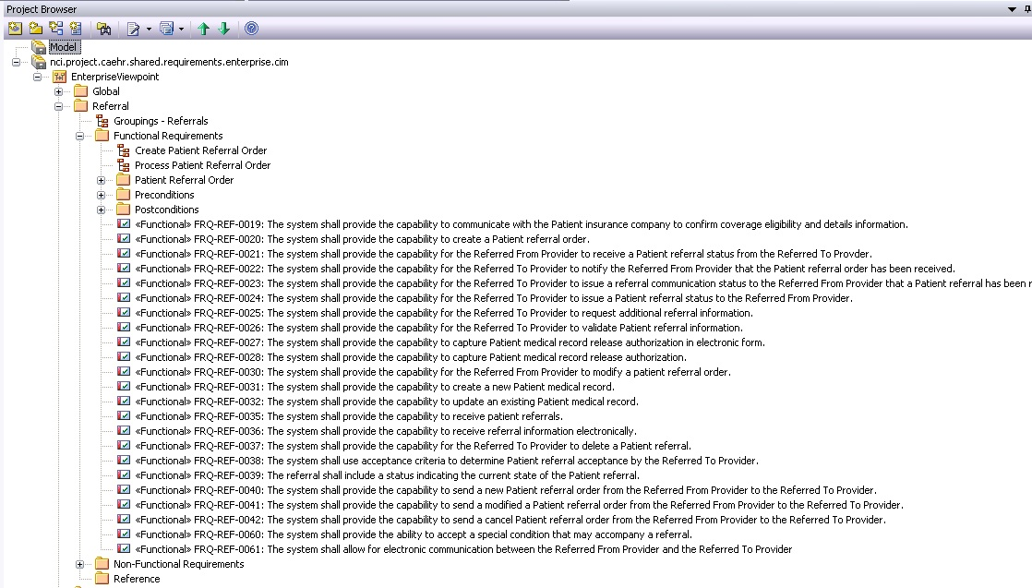

JAMA Contour is a requirements management product which will be used to connect requirements from EA to Jira and HP Quality Center. Contour has many other features that the A&A team may use including change management capabilities such as version history, side-by-side comparisons, change requests and full activities tracking for auditing. http://www.jamasoftware.com/contour/features.php
To Do: Examples of Contour requirements linkage to be added once caBIG use of Contour becomes available.
Hewlett Packard Quality Center (HP QC) will be used for test case management, which includes a defect tracking tool as well. Defects will be entered by QA into the QC defect tracker, and a synchronizer called JIRA Bridge will be used to create corresponding JIRA issues that are synchronized both ways as updates are made.
Illustration of a Requirement stored in HP Quality Center
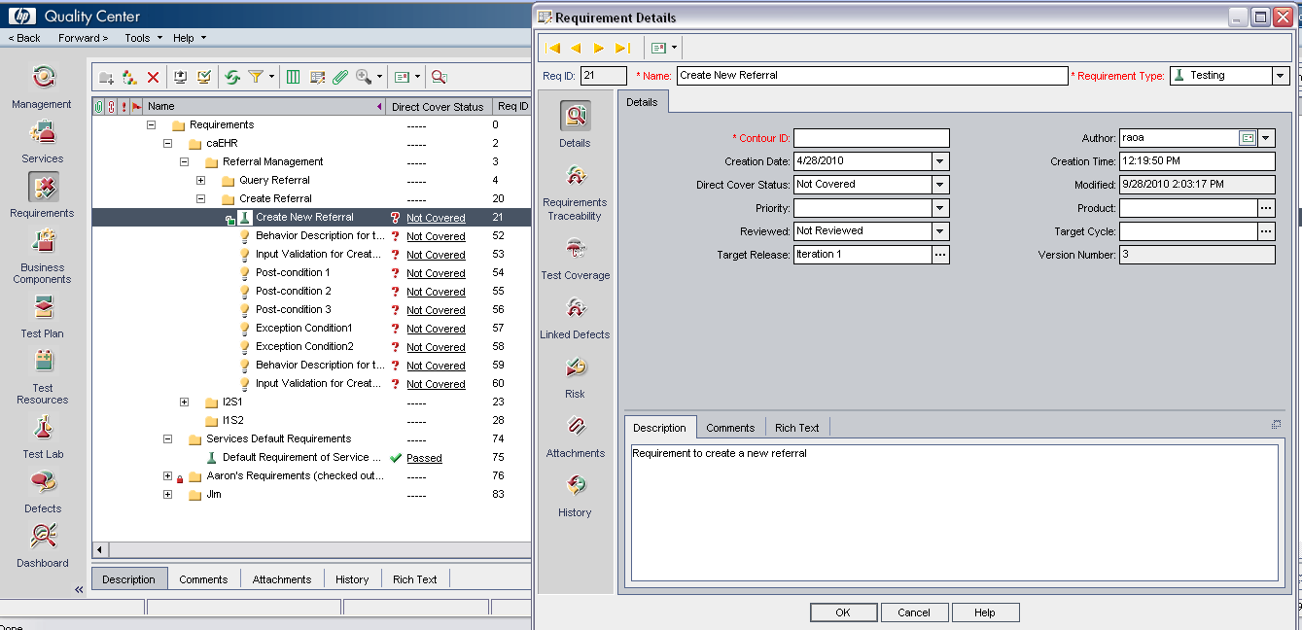

JIRA Studio is the central issue and activity tracking tool used by the project to support the Agile development process. It will be the central caBIG location for all defects. Linkages are planned between JIRA and Contour and HP QC to allow tracking of defects back to test cases and originating requirements.
To Do: Examples of JIRA defects linkage requirements to be added once caBIG use of HP QC and Contour becomes available.

